

|  |
| --- |
| **User Requirement Study ( URS ) for Web** |

**Version Management:**

|  |  |  |  |
| --- | --- | --- | --- |
| Version | Date | Editor | Changes |
| 0.1 | 2017-07-16 | Arsar | First draft. |
| 0.5 | 2017-10-01 | Arsar | Added User Roles |
| 0.6 | 2017-10-04 | Arsar | Fine tune based on Aflix Team input |
|  |  |  |  |
|  |  |  |  |
|  |  |  |  |
|  |  |  |  |

TABLE OF CONTENTS

1 Introduction 3

1.1 Objective 3

1.2 Overview 3

2 Requirement Overview 3

2.1 Functions Overview 3

2.2 User description 7

2.3 Type users in the platform 8

2.4 User Signup/ Login Module 8

3 User Roles & Content 10

3.1 Public Content & Users 10

3.2 Free Registered Content & Users 11

3.3 Paid Subscriber Content & Users 14

3.4 Premium VOD Content 18

3.5 Contributor Content & User 21

3.6 Corporate Admin 26

3.7 Corporate Users 27

3.8 Super Admin 28

# Introduction

This is a User Requirement Study (URS) Document which will explain the detailed requirement and the process of the Aflix Platform – Ethical Entertainment Platform

## Objective

The objective of this document is to identify the requirement in term of functionality, process & scope of Aflix – Ethical Entertainment Platform.

## Overview

Aflix is an Ethical Entertainment platform. It operates in four main segments: Free Registered users, Paid Subscribers, Premium Video on Demand (VOD) and Live Streaming content, Corporate Users content and Contributor Content. The platform will offer TV Shows, Documentaries, and Premium Movies via VOD service. It offers members with the ability to receive streaming content through a host of Internet-connected screens and mobile devices. The company also provides contributor membership services. Anyone with their own videos can submit to the platform and get revenue from the public member’s viewership.

Aflix allows users to view, rate, share, add to favourites, report, and comment on videos. Available content includes video clips, TV show clips, music videos, short and documentary films, movie trailers, live streams, and other contents. Contributors and admin both can upload desired content. All users required to be registered in order to watch the videos. If the users want to watch a premium subscriber’s content , they can upgrade to monthly or yearly plan. Any users can also purchase a Premium VOD which could be “rented” or watched for the next 30 days after the purchase.

Aflix also have a special corporate users segment, which allows an organization to register their whole lot of users into Aflix platform. In exchange with the bulk signup, Aflix could grant selected number of videos from the paid subscriber’s content to be assigned to the corporate users group. Different organization may have different videos be assigned based on Aflix team’s decision.

Aflix earns advertising revenue from pre roll video, which targets ads according to site content and audience. The vast majority of its videos are free to view for registered users, but there are exceptions, including subscription-based premium video, as well as Premium VOD.

All Aflix users can upload videos. Users who have a good track record of complying with the site's Community Guidelines may be offered the ability to live streams subject to Aflix’s approval, which requires verification.. Aflix accepts videos that are uploaded in most container formats, including AVI, MP4, MPEG-PS, QuickTime File Format and FLV

# Requirement Overview

## Functions Overview

### Subscription service

Aflix monthly subscription fee is 1 USD and yearly subscription fee is 10 USD. User can avail to watch paid and premium contents.

### Live TV

Aflix announces that it is begin offering an [over-the-top](https://en.wikipedia.org/wiki/Over-the-top_content) [IPTV](https://en.wikipedia.org/wiki/IPTV) service with "live programming from broadcast and cable brands". The service, marketed only as “Live TV," which couples the live TV offerings with Aflix existing library of television series and films.

### User Comments

All videos enable users to leave comments, and these will attract attention for the [negative](https://en.wikipedia.org/wiki/Troll_(Internet)) aspects of both their form and content.

### VOD

Premium Contents are the video content that made available to all the subscribers via various prices. Once users pay for the premium content they can continue to watch if for 30 days from the date of payment.

### Free Registered Users

The content classified as for “Registered Users Content”. Any “Free Registered Users” can watch this content by logging in using email and password

### Contributor

Contributor module is a section that allow the users to contribute their own videos into Aflix platform & make money based on the views

Users can sign up as Contributor by Clicking the “Contribute” Button, same information will be collected like free registered users

### Corporate Admins

A special admin that could only be created by the superadmin, this admin is created to manage the users for a group or organization that signup to Aflix. Corporate admin have permission to create corporate users and upload the corporate users via csv

### Super Admin

A super admin that can add all type of users and can view the overview dashboard

### Live Streaming

Live streams will be added to Aflix. Broadcast your events in up to 1080p – this is really depend on the broadcasters equipment and bandwidth , Adaptive streaming means viewers get the best quality across devices, even with limited bandwidth.

### Website flow

Functionality and flow can be read below.

|  |  |
| --- | --- |
| User | Role |
| Public User | * Public user can signup * Public user can login * Public user access public content * Public user cannot access to registered content as well paid subscriber content. * Public user cannot create users as well as corporate user * Public user cannot see selected corporate user content * Public user cannot have access to live videos |
| Free Registered User | * Free registered users are registered on the site * Free registered users can login * Free registered users have access to public content as well as registered content * Free registered uses cannot access to paid subscriber’s content * Free registered users can access to premium content if and only if purchases premium * Free registered cannot create users as well as corporate user * Free registered cannot see selected corporate user content * Free registered cannot have access to live videos |
| Paid Subscribers | * Paid registered users are registered on the site * Paid registered users can login * Paid registered users have access to public content as well as registered content * Paid registered uses can access to paid subscriber’s content * Paid registered users can access to premium content if and only if purchases premium * Public user cannot create users as well as corporate user * Public user cannot see selected corporate user content * Public user cannot have access to live videos |
| Corporate Admin | * Corporate Admin are registered on the site * Corporate Admin can login * Corporate Admin have access to public content as well as registered content * Corporate Admin cannot access to paid subscriber’s content * Corporate Admin can access to premium content if and only if purchases premium * Corporate Admin cannot create users but able to create corporate user * Corporate Admin cannot see selected corporate user content * Corporate Admin cannot have access to live videos |
| Corporate Users | * Corporate Users are registered on the site * Corporate Users can login * Corporate Users have access to public content as well as registered content * Corporate Users can access to paid subscriber’s content if upgraded to paid * Corporate Users can access to premium content if and only if purchases premium * Corporate Users can view selected paid subscribers content based on assignment by the Superadmin * Corporate Users cannot have access to live videos |
| Contributor | * Contributor are registered on the site * Contributor can login * Contributor have access to public content as well as registered content * Contributor can access to paid subscriber’s content if upgraded to paid * Contributor can access to premium content if and only if purchases premium * Contributor cannot create users and corporate user * Contributor cannot have access to live video |
| Super Admin | * Super Admin can login * Super Admin have access to public content as well as registered content * Super Admin can access to paid subscriber’s content * Super Admin can access to premium content * Super Admin can create users and corporate user * Super Admin cannot see selected corporate user content * Super Admin can have access to live videos |

### Aflix Home page overview & concept



The homepage have the following Menus

* SHOWS
  + Type of shows that will be listed in Aflix platform
  + Live
    - A live videos page
    - To have a chat room for the live user to interact or asking questions related to live video
    - Could be used to chat among the users as well
* Search box
* Contributor Modules
* Sign Up & Login page
* Main slider which shows the latest posts uploaded (user need to check show in the slider option). These could be overridden using slider management option
* 4 row of the latest videos from a category. This could be configured in the setting on which categories will be shown

## User description

|  |  |
| --- | --- |
| User/Content | Description |
| Public Users | Any users that are visiting the site by directly typing in [www.Aflix.tv](http://www.aflix.tv) or coming via search engine results |
| Public Content | any content that could be viewed by public users without any registration, these content are static pages like About Us page, Contact us page etc |
| Free Registered users | Users required to register by providing all the information required in 2.4, Once registered a confirmation email will be sent. Users not required to click for conformation |
| Registered Content | The content classified as for “Registered Users Content” any “Free Registered Users” can watch this content by logging in using email and password |
| Paid Subscribers | Users that registered with information required in 2.4 and pay a subscription fee of USD1 per month or USD10 per year. |
| Paid Subscribers content | The content classified as “Paid subscribers content” |
| Corporate Admin | A special admin that could only be created by the superadmin, This admin is created to manage the users for a group or organization that signup to Aflix. Corporate admin have permission to create corporate users and upload the corporate users via csv. |
| Corporate Content | Corporate contents are the content allowed for the corporate users. Basically all registered content are allowed for the corporate users because all the corporate users are a registered users as well. Super admin can assign some content from the paid subscribers content to the corporate users due the corporate agreement with Aflix |
| Corporate Users | The Aflix members who have a special collaboration with Aflix. All Corporate users are considered as a free registered users. Corporate users will be able to watch some special paid subscriber’s content that assigned by the superadmin. The special paid subscriber videos are differ from an organization to organization. The organization can be a large company, school, kindergarten or association. |
| Contributor | Contributor is a type of user who can contribute their videos to be distributed via Aflix platform. Contributor can contribute video either in Registered Content, Paid Subscriber Content and Premium Content. The revenue will be discussed in the Contributor section later. Contributor can be organization or individual |
| Premium VOD Content | Premium Contents are the video content that made available to all the subscribers via various prices. Once users pay for the premium content they can continue to watch if for 30 days from the date of payment. |
| Superadmin | Superadmin is a superuser that have full access to create users, upload content, and approve content, view revenue and more. Will be discussed in detail in superadmin section |

|  |  |  |  |  |  |  |  |  |
| --- | --- | --- | --- | --- | --- | --- | --- | --- |
|  | Public  Content | Registered  Content | Paid Subscribers   Content | Premium VOD Content | Create  User | Create  Corporate  User | selected corporate  user content | Live Video |
| Public User | X |  |  |  |  |  |  |  |
| Free Registered User | X | X |  | X ( if purchase Premium) |  |  |  |  |
| Paid Subscribers | X | X | X | X ( if purchase Premium) |  |  |  |  |
| Corporate Admin | X | X |  |  |  | X |  |  |
| Corporate User | X | X | X (if upgrade to paid ) | X ( if purchase Premium) |  |  | X | X (if upgrade to paid ) |
| Contributor | X | X | X (if upgrade to paid ) | X ( if purchase Premium) |  |  |  | X (if upgrade to paid ) |
| Superadmin | X | X | X | X | X | X |  | X |

## Type users in the platform

## User Signup/ Login Module

Signup is required for all new users in following

* Free Registered Users
* Paid Subscribers

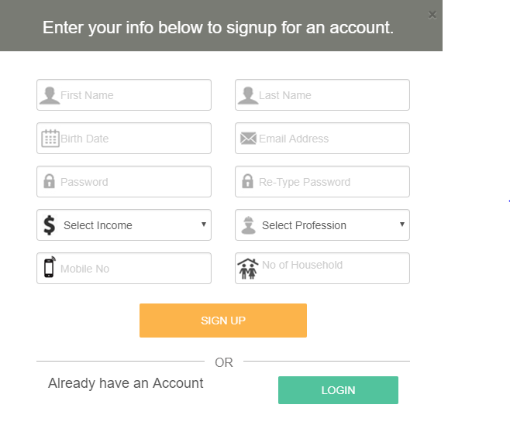

User signup & login are shown in the same interface like many famous portals example: Netflix

The required information by the stakeholders are. All fields are mandatory

|  |  |
| --- | --- |
| Parameters | Description |
| First Name | First Name, supports characters & numbers |
| Last Name | Last Name, supports characters & numbers |
| Date of Birth | Format, MM/DD/YYYY,Can type or select from the option provided. Dropdown menu to select the year. |
| Email address | Standard email format. Able to detect existing email immediately |
| Income | Can only select from the dropdown menu. Options are   * Below $1000 * $1001-$3000 * $3001-$5000 * $5000 & above |
| Profession | Can only select from the dropdown menu. Options are   * Manager * Executive * Clerk * Business Owner   Government |
| Mobile No | Supports only numbers. |
| No of households | Supports only numbers |

# User Roles & Content

## Public Content & Users

Any users that are visiting the site by directly typing in [www.Aflix.tv](http://www.aflix.tv) or coming via search engine results

Pages that are allowed for any visiting public users. The pages are classified as “Public Content”. Example of public content are “About Us, Terms & Conditions, and Contact Us. Promotional Videos also could be used as Public Content. These are generally static pages. The content could be classified by the Aflix Stakeholders.



### Clicking on Public Content

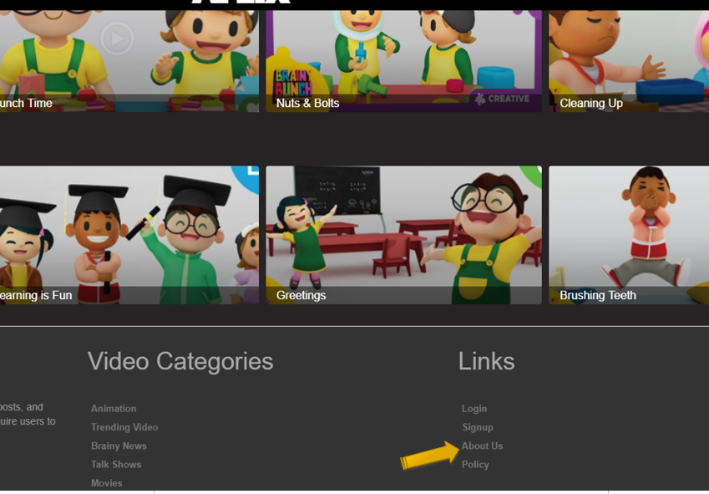

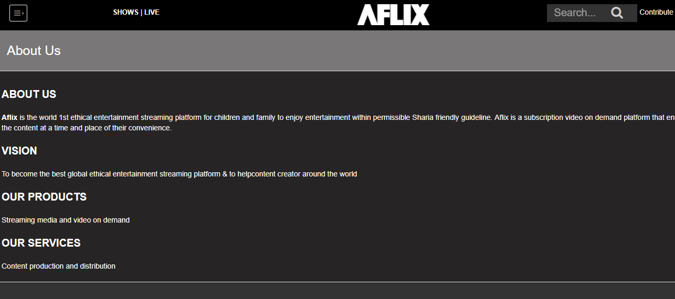

## Free Registered Content & Users

The content classified as for “Registered Users Content”. Any “Free Registered Users” can watch this content by logging in using email and password. If the user not registered yet, users required to register by providing all the information required in 2.4, once registered a confirmation email will be sent. Users not required to click for conformation. Here is the flow.

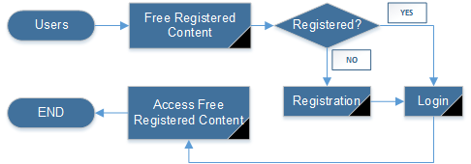

### A Public User Clicking on Free Registered Content

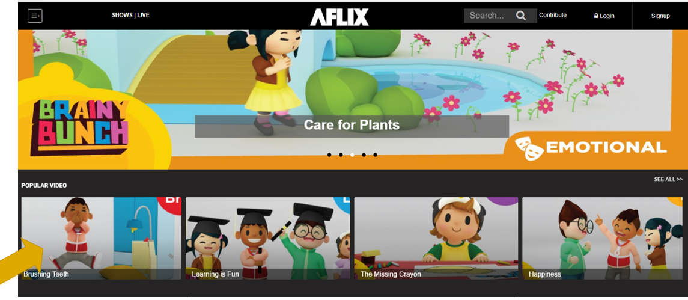

### It will give a message “Sorry, this video is only available For Registered Users”

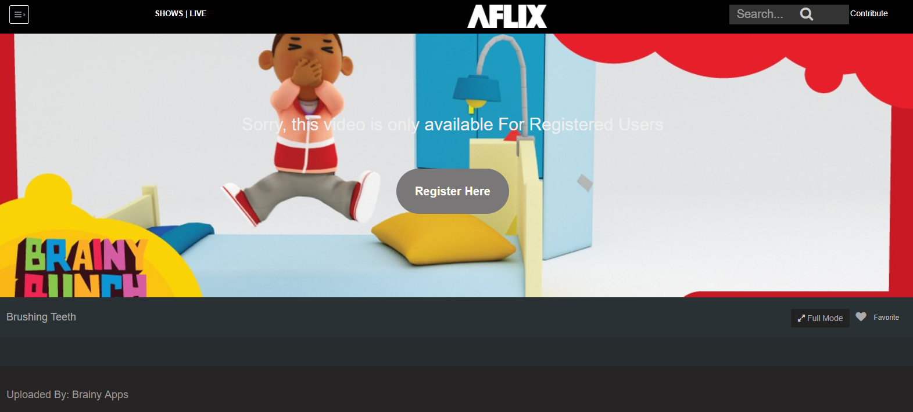

### When clicked the “Register Here”. There will be 2 options “Sign In” and “Sign Up

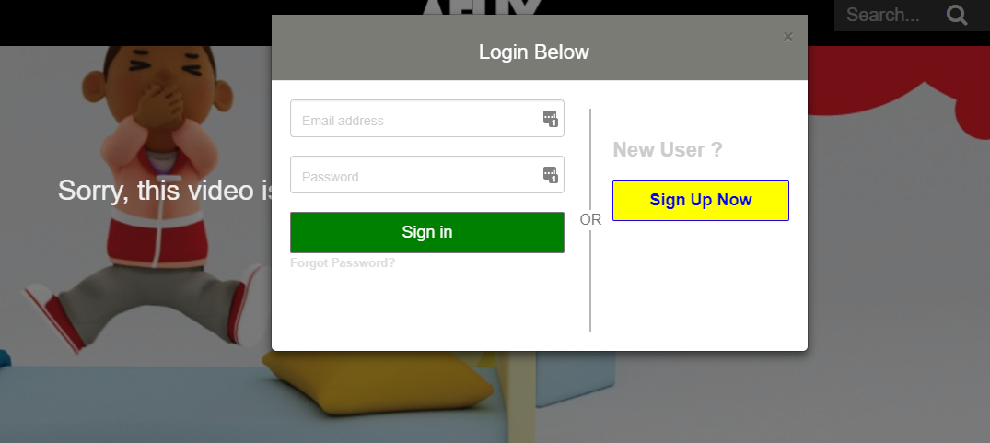

### The case here for New User. Click “Sign Up Now”

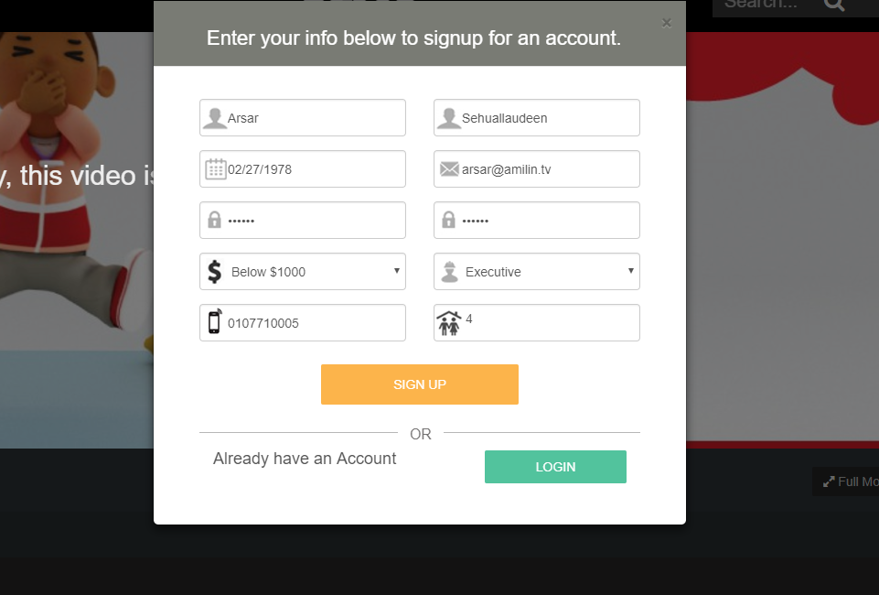

### It will redirect to login page, at the same time email will be sent to the registered email address

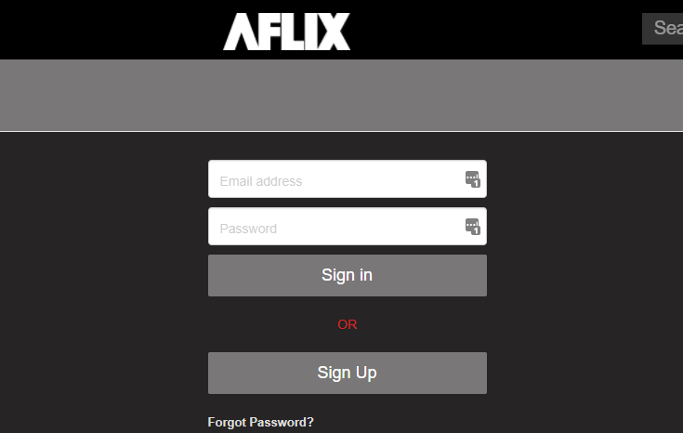

### Once login, the earlier selected video should play automatically



### Email screenshot [to be added]

### Once login, the earlier selected video should play automatically

In reference to 3.2.3, If the user already registered can just login using the username and password, then it will go to 3.2.6

## Paid Subscriber Content & Users

Paid Subscriber Contents are provided by charging the users USD1 per month or USD10 per year. Users that registered with information required in 2.4 and pay a subscription fee of USD1 per month or USD10 per year.

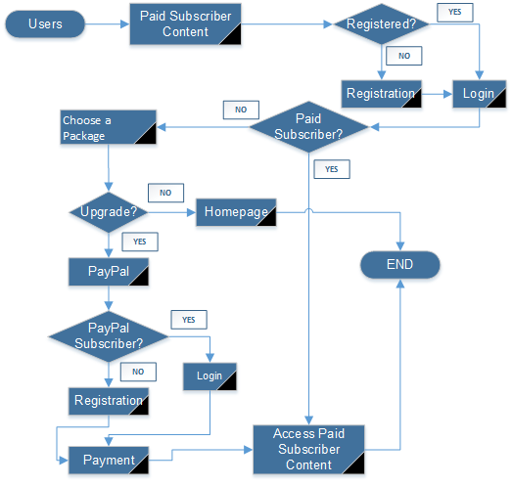

### A Public User Clicking on Free Registered Content

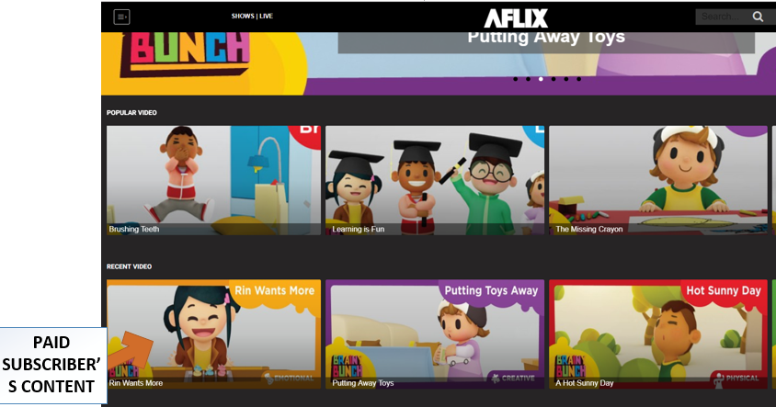

### A Public User Clicking on Paid Subscriber’s content

There will be a trailer or teaser to see. Then user can Click “Subscriber Now”

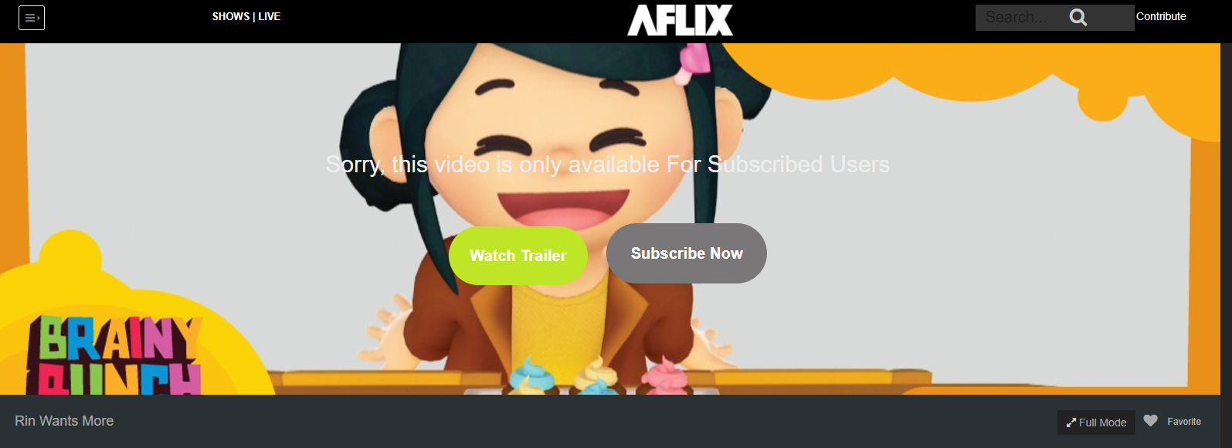

### A Public User Clicking on Paid Subscriber’s content

If user is new, can click the signup option, if it’s an existing user can just click login



### After logging in, system will check for the user level, if the user is a free registered user, it will prompt for upgrading to subscriber



Once user clicked subscriber now, it will take into a paypal payment page

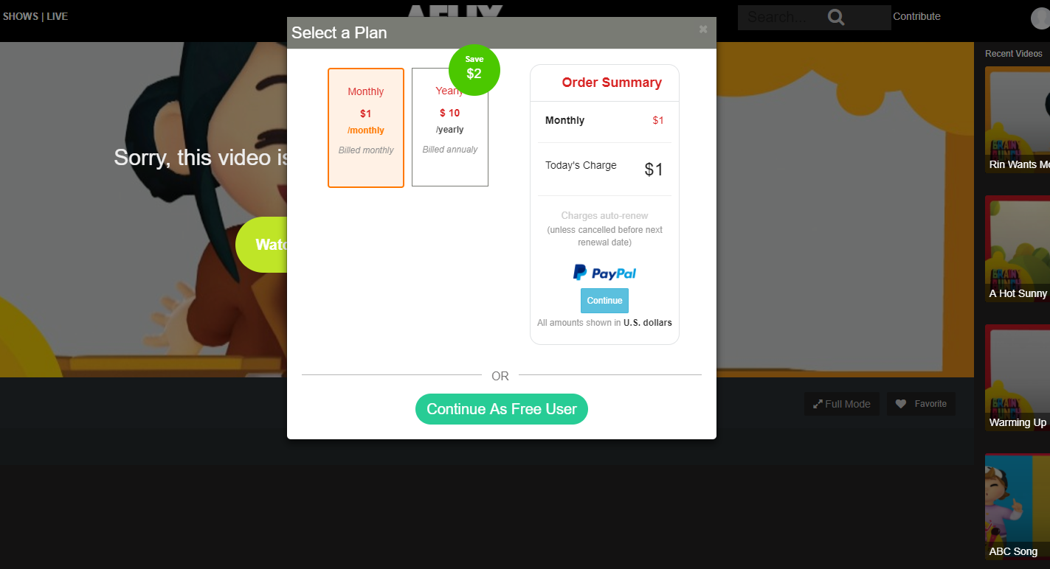

User can select a monthly or yearly option. The click continue to Paypal

Then it will be taken into purchase page, Click “Purchase Now”. User can add in any discount coupon if its available

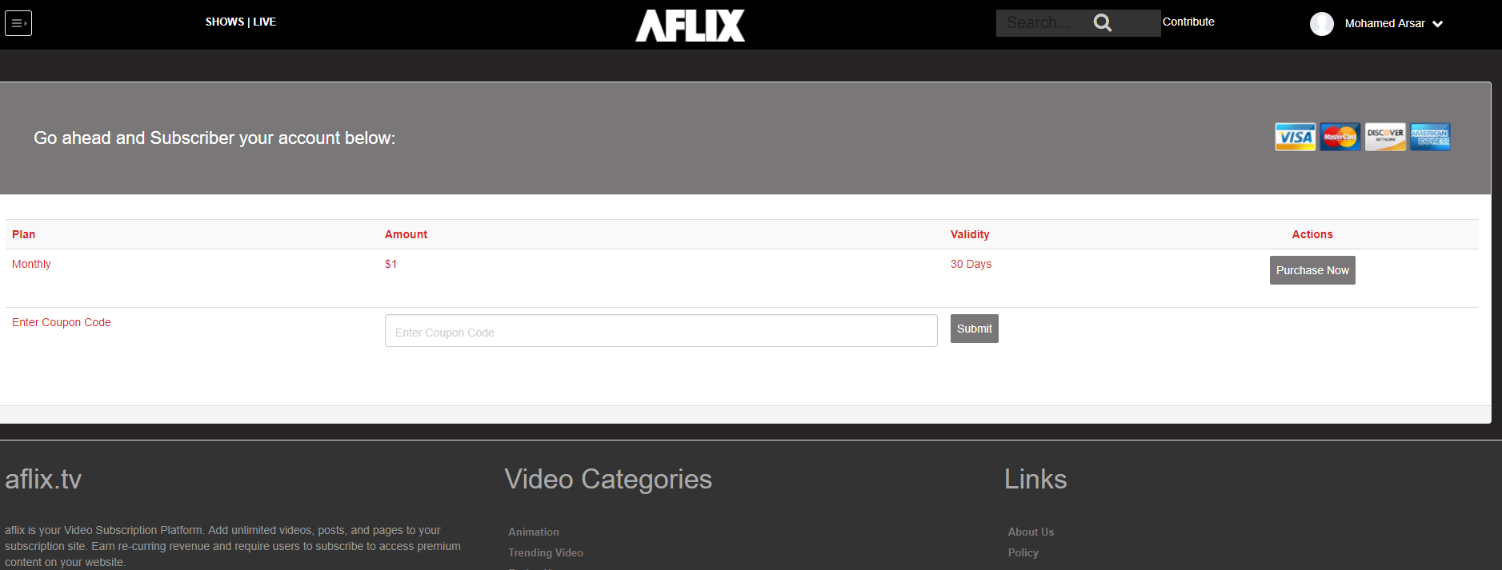

Then user will be taken into Paypal login page, if it’s a new user, user can signup for a paypal account and make payment. Once Payment Completed, it will be redirected back to the originally clicked video and the video will continue to play

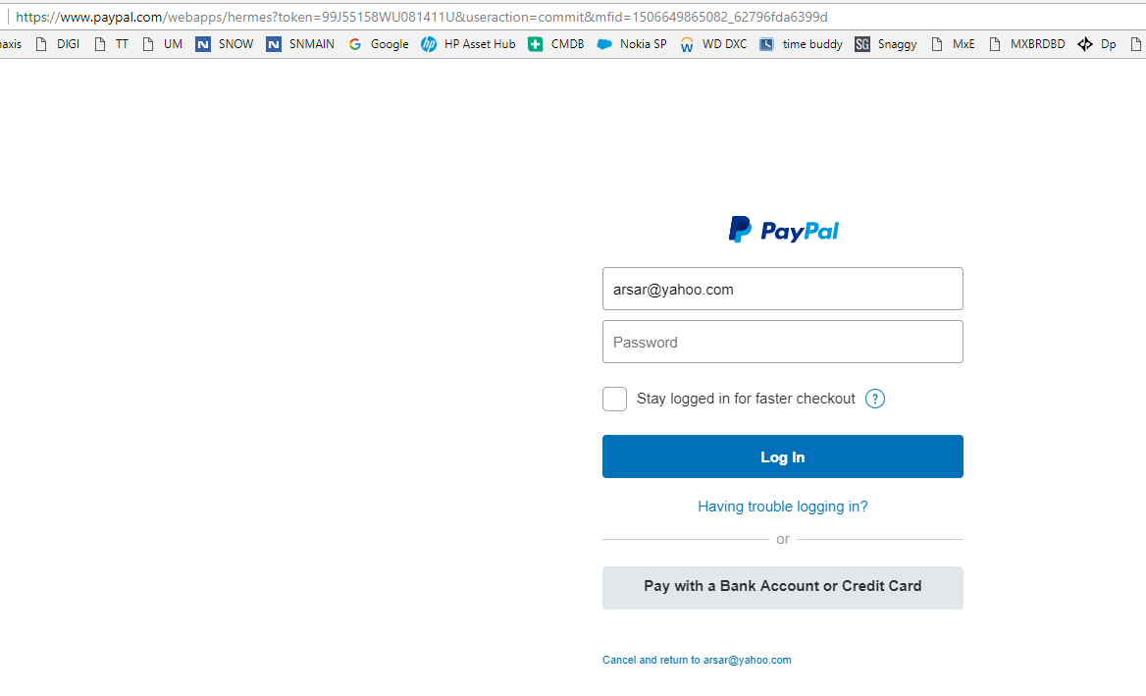

## Premium VOD Content

Premium Contents are the video content that made available to all the subscribers via various prices. Once users pay for the premium content they can continue to watch if for 30 days from the date of payment.

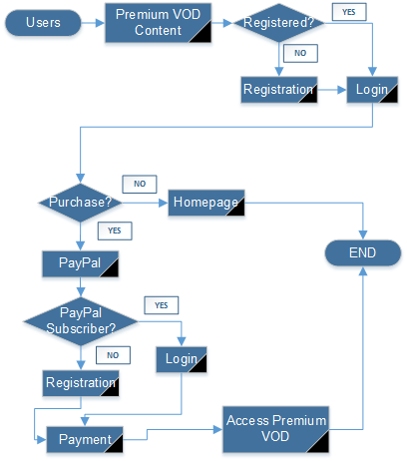

### User (Free Registered User, Paid Subscriber) Clicking the Paid VOD



System will automatically check that user is login or not if user is a new user or not login yet then system will show prompt login screen



If user is already registered on this website then simply login to the system if not then register to website and then login. Once login, the price of the video will be displayed, then click “Purchase Now”

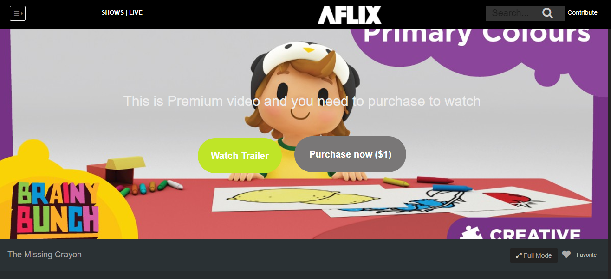

Price will be shown

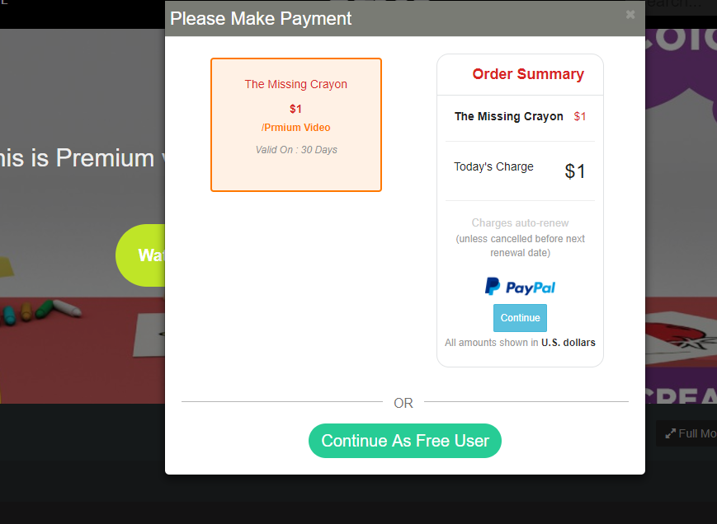

Continue to make payment and watch the video for 30 days

## Contributor Content & User

Contributor module is a section that allow the users to contribute their own videos into Aflix platform & make money based on the views

Users can sign up as Contributor by Clicking the “Contribute” Button, same information will be collected like free registered users

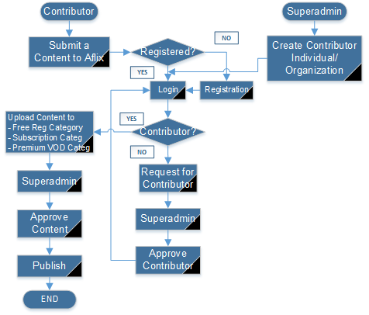

### Become a Contributor

A contributor visits Aflix and then click on contributor button

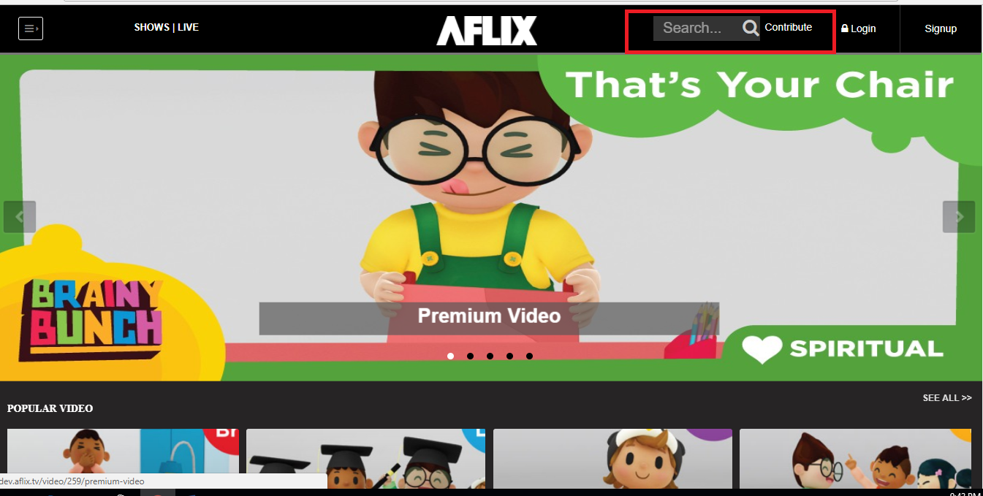

A popup screen opens it will ask that user is registered or not. If no then registered



3.5.2 Sending Request for Contributor

System will check either signed user is contributor or not if not then user needs to request for contributor to super admin and will wait for approval

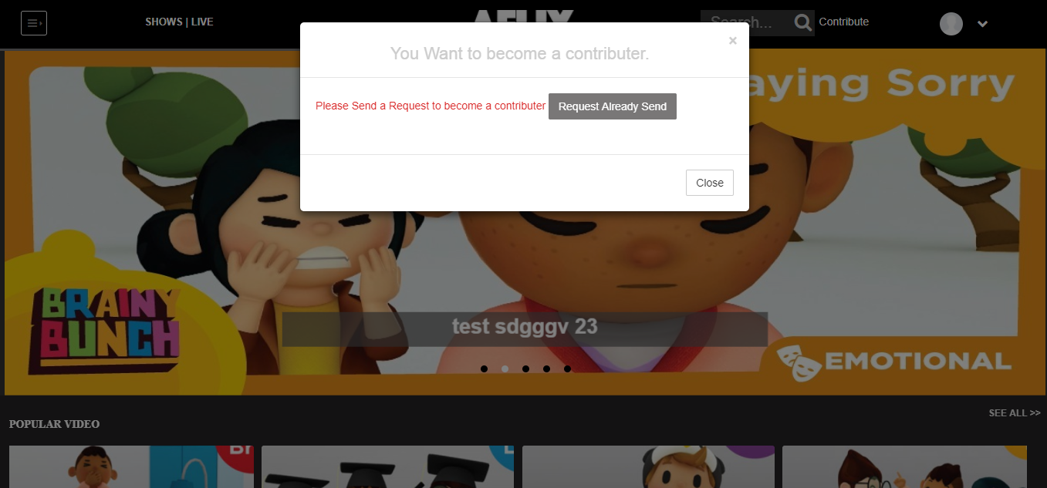

3.5.3 Wait for admin approval

Super admin will watch the content if this content is legal and eligible to approve then admin will approve it if not then admin will not approve it and content will not publish.

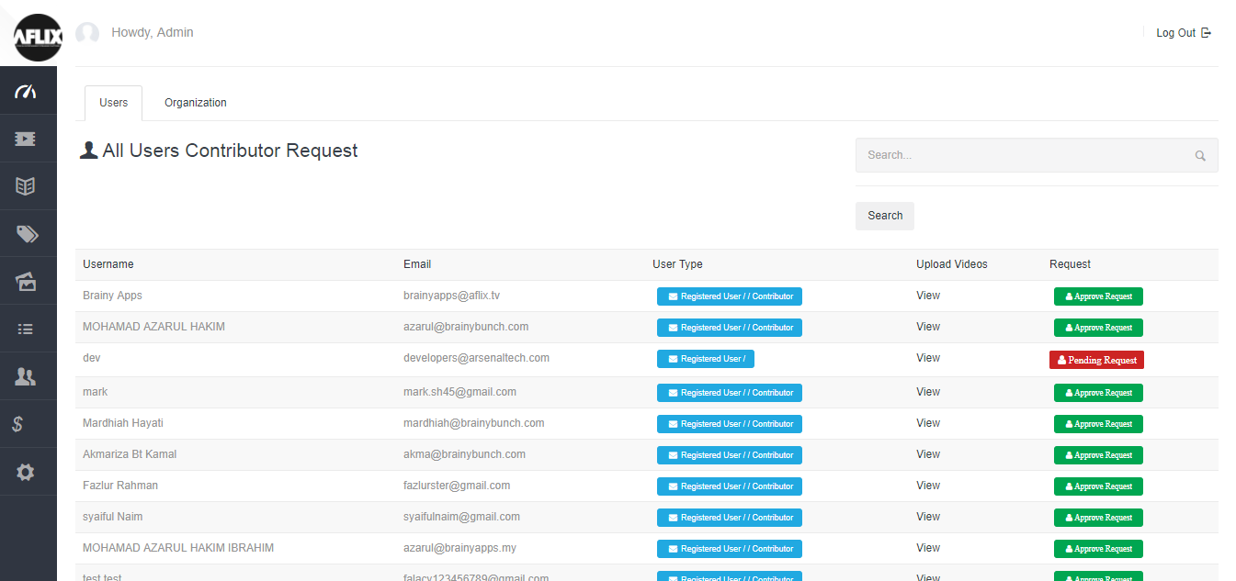

Then user will login to contributor. And system will check user is contributor or not

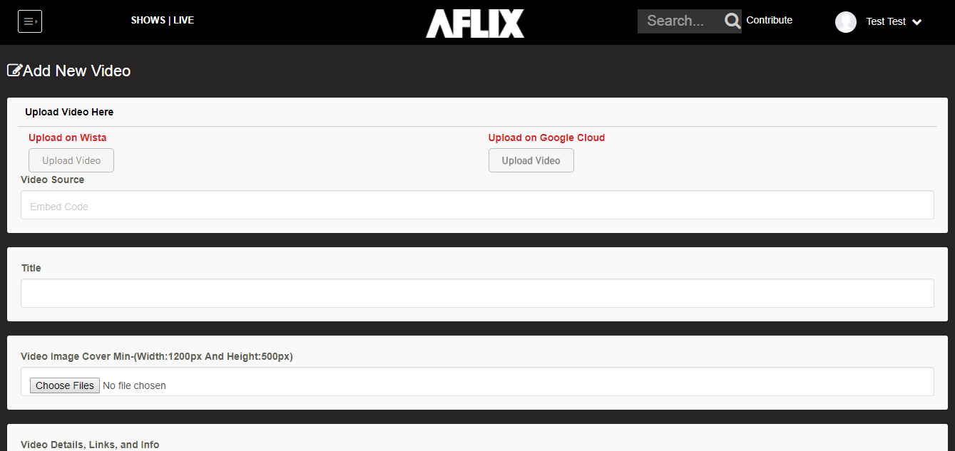.

3.5.4 Start uploading content

If yes user will upload content to free registered category subscription category premium VOD category

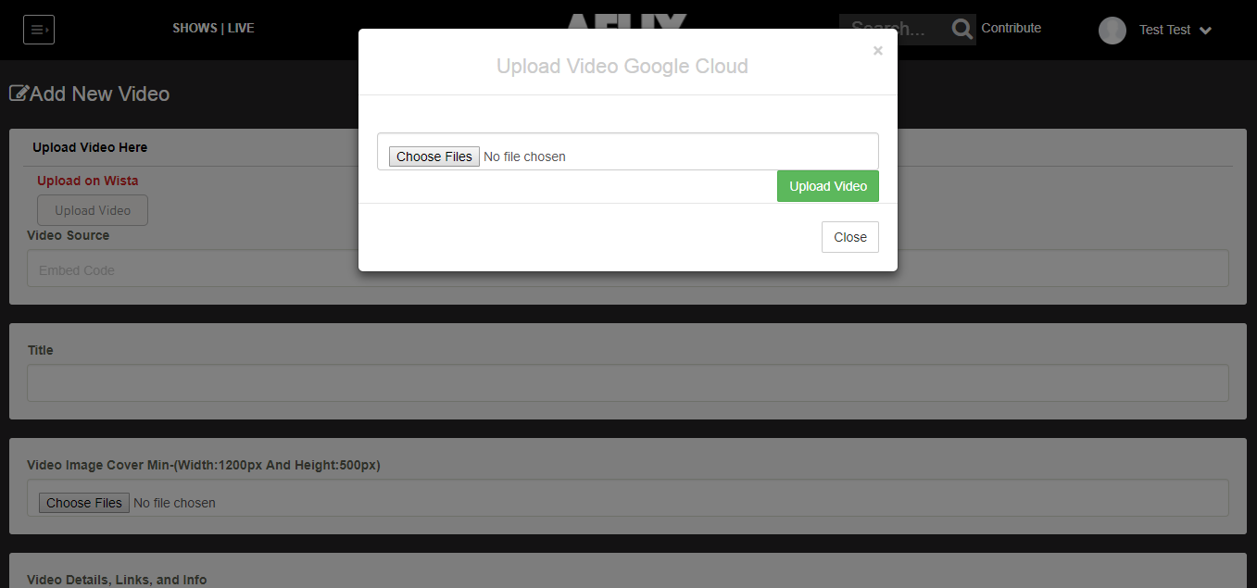

After uploading the content request will goes to super admin and super admin will approve the content then it will be published.

### How Contributor revenue works

Following table describes how revenue will work for paid subscriber contents

|  |  |  |
| --- | --- | --- |
| Description | Example | Units |
| Price per subscriber per month | 1.00 | usd |
| Let's say total paid subscribers /monthly basis | 6000 | users |
| Total subscriber yearly basis USD10/year so USD0.83 | 20 | users |
| Total revenue ( USD1x6000 ) + ( USD0.83x 20) | 6,016.60 | usd |
| if contributor A's paid subscriber videos plays | 500 | views |
| Sitewide paid subscribed video play | 8500 | views |
| Cont A % video play 500/8500 | 0.058 | revenue |
| Cont A Gross revenue 6016.60 x 0.058 | 348.9628 | usd |
| Contributor A % revenu ( 40 : 60 ) (Cont A : Aflix) | 139.5851 | usd |

Following table describes how revenue will work for Premium VOD

|  |  |  |
| --- | --- | --- |
| for Premium video | Example | Units |
| Movie A | 2.00 | usd |
| Total views | 200 | views |
| Total revenue 2 x200 | 400.00 | usd |
| Rev share to movie contributor ( 70 : 30 )(Cont:Aflix) | 280.00 | usd |

## Corporate Admin

A special admin that could only be created by the superadmin, This admin is created to manage the users for a group or organization that signup to Aflix. Corporate admin have permission to create corporate users and upload the corporate users via csv.



The Aflix members who have a special collaboration with Aflix. All Corporate users are considered as a free registered users. Corporate users will be able to watch some special paid subscriber’s content that assigned by the superadmin. The special paid subscriber videos are differ from an organization to organization. The organization can be a large company, school, kindergarten or association.

### Create the Corporate Admin

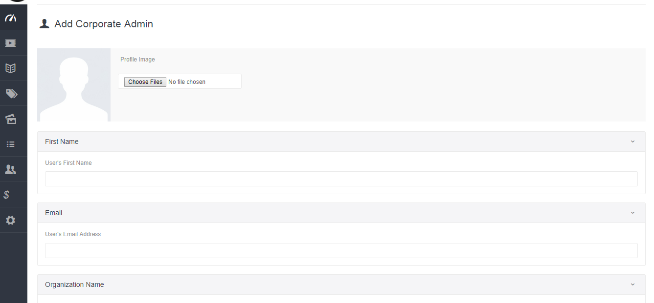

## Corporate Users

Aflix also have a special corporate users segment, which allows an organization to register their whole lot of users into Aflix platform. In exchange with the bulk signup, Aflix could grant selected number of videos from the paid subscriber’s content to be assigned to the corporate users group. Different organization may have different videos be assigned based on Aflix team’s decision. Here is the corporate user flow. The flow is quite straight forward .

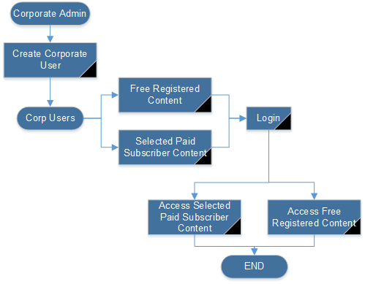

## Super Admin

There is no user flow created for Super Admin as the user level have the highest privilege.

In summary Super Admin can do the following

### Able to See Dashboard with the following information

* Total Subscribers
* New Subscribers
* Total no of Videos
* Total Registered users
* Total New Registered Users
* Total Premium Videos
* Total Videos
* Total Corporate Admin
* Total Contributors
* Summary of the visitors dashboard based on Google Analytics

### Video Section

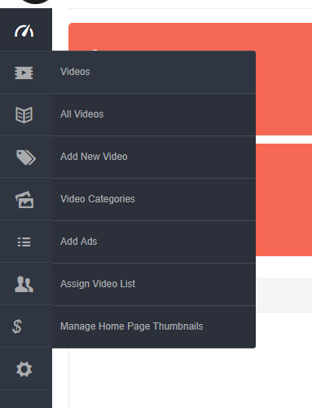

* All Videos

Will show list of videos with option to

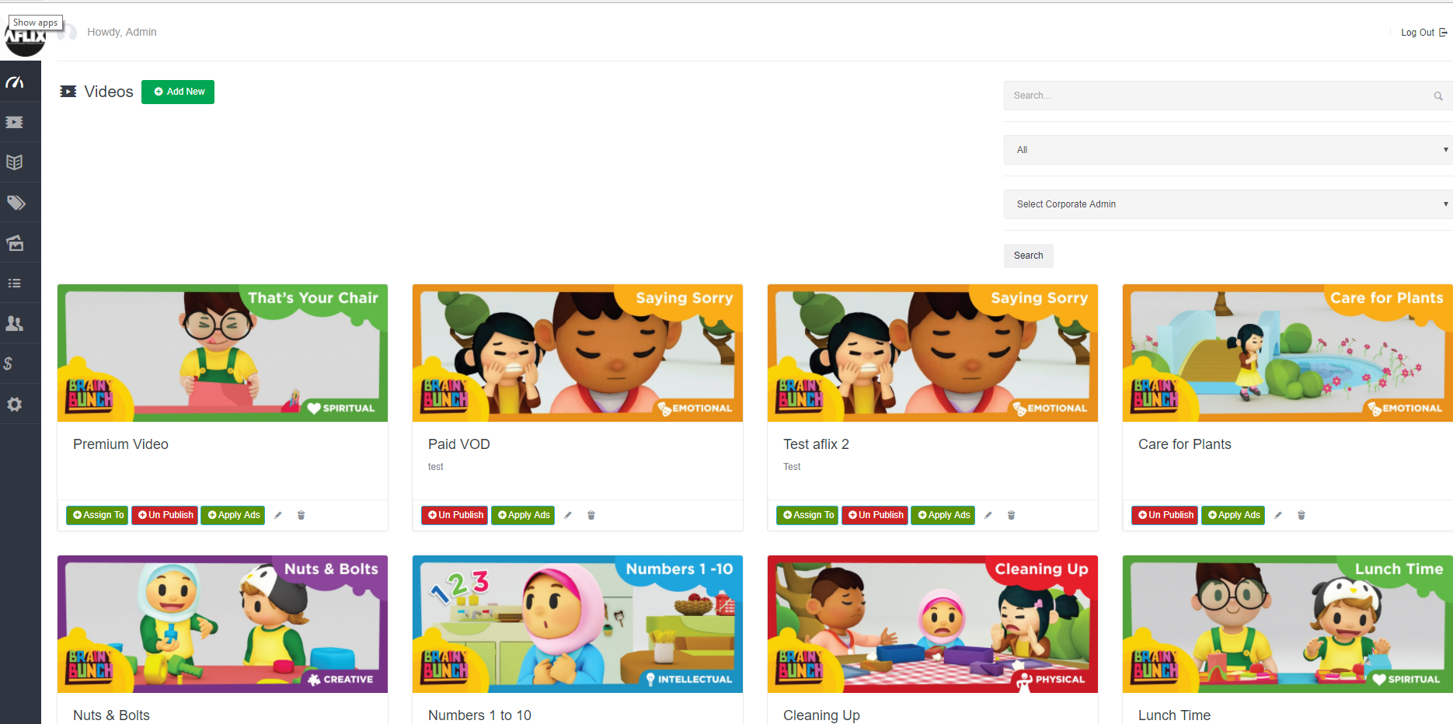

* New Subscribers
* Total no of Videos
* Total Registered users
* Total New Registered Users
* Total Premium Videos
* Total Videos
* Total Corporate Admin
* Total Contributors
* Summary of the visitors dashboard based on Google Analytics

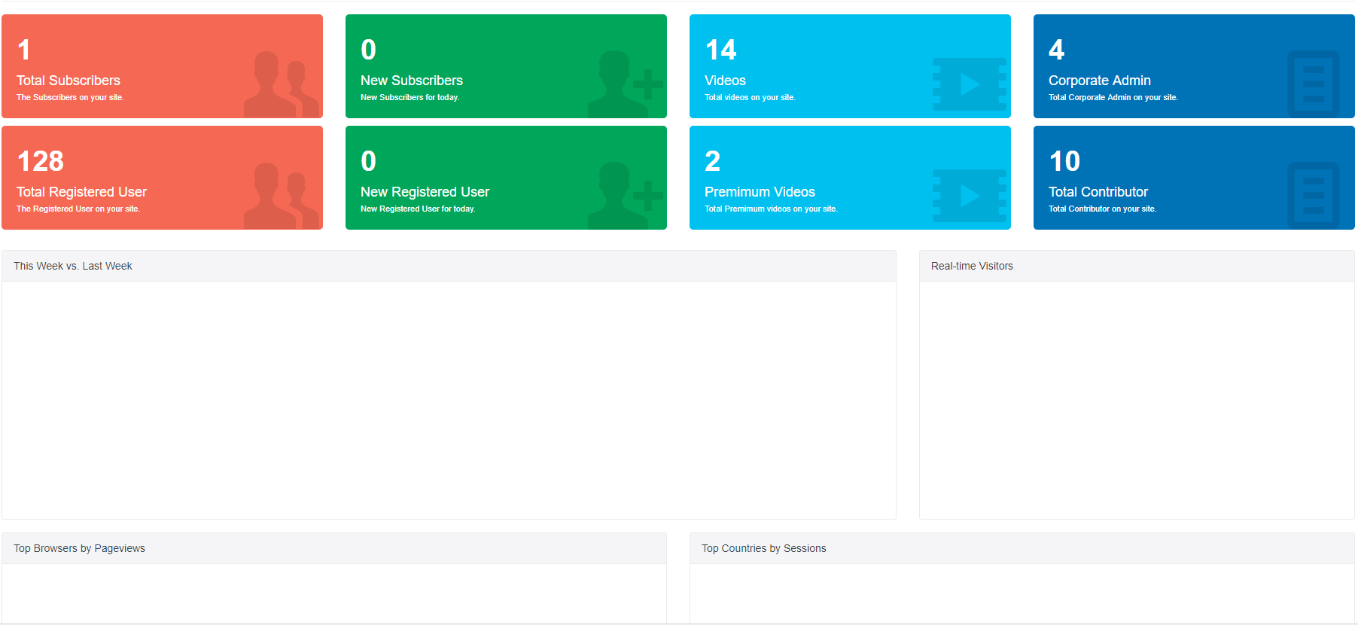

### Admin can add videos

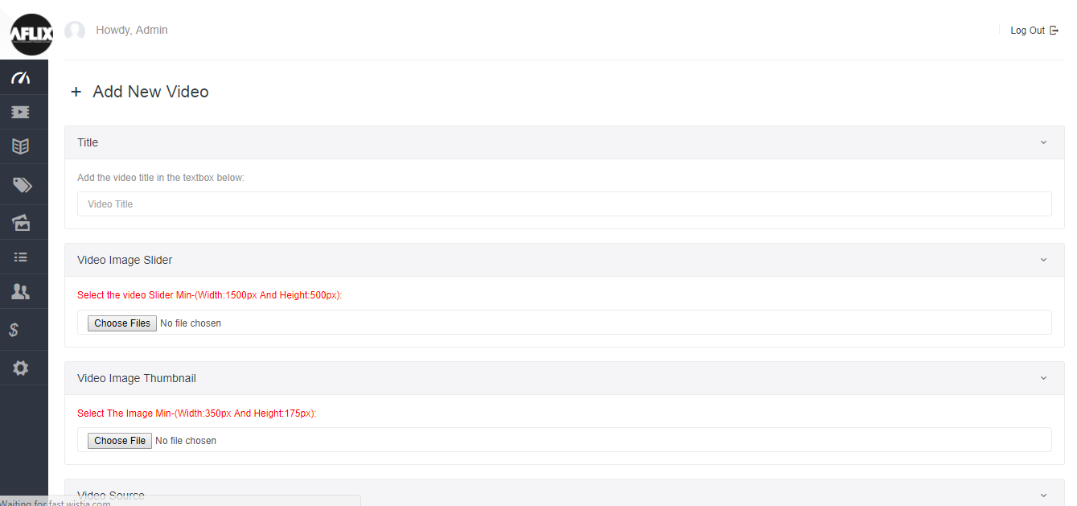

### Admin can add video category

In this section admin can add new categories admin can delete it and admin can edit it.

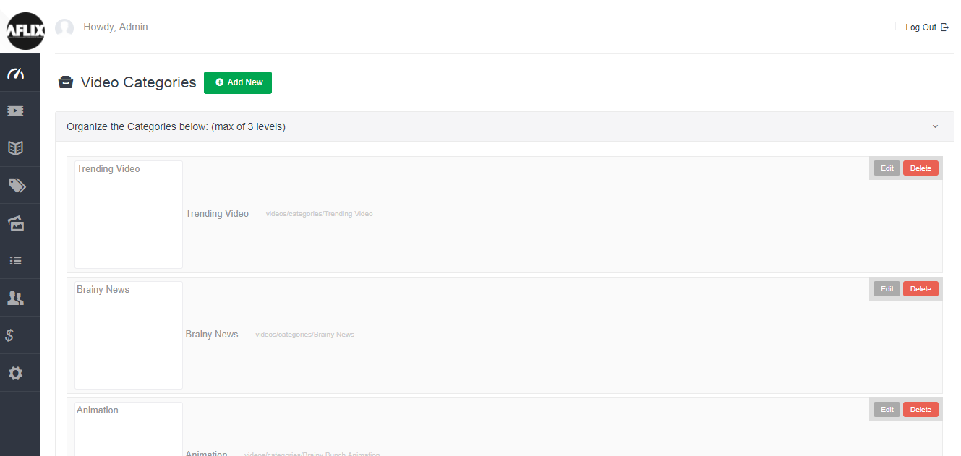

Admin also can edit the categories

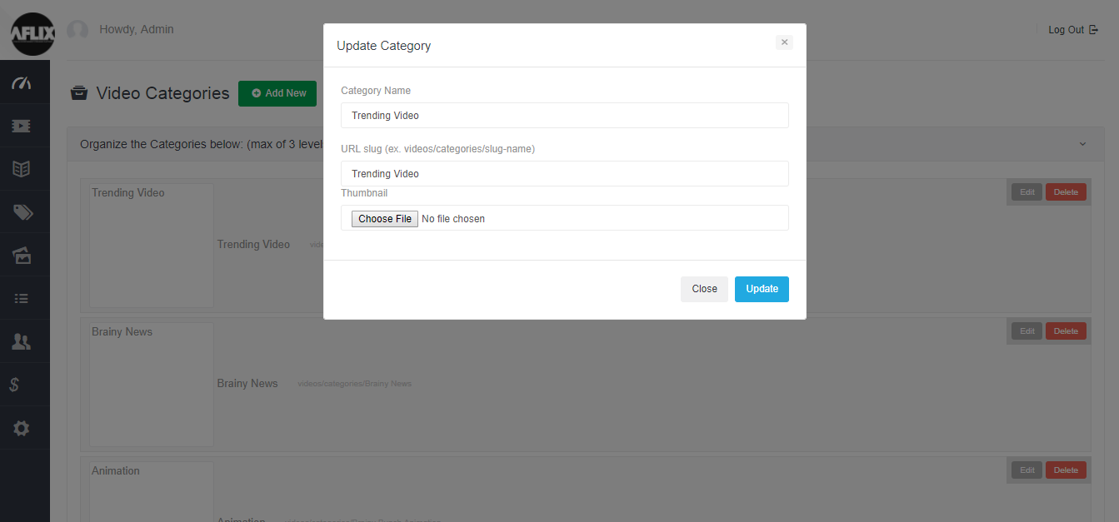

### Add advertisements

In this section admin can add new adds. Admin can edit the ads and can delete it

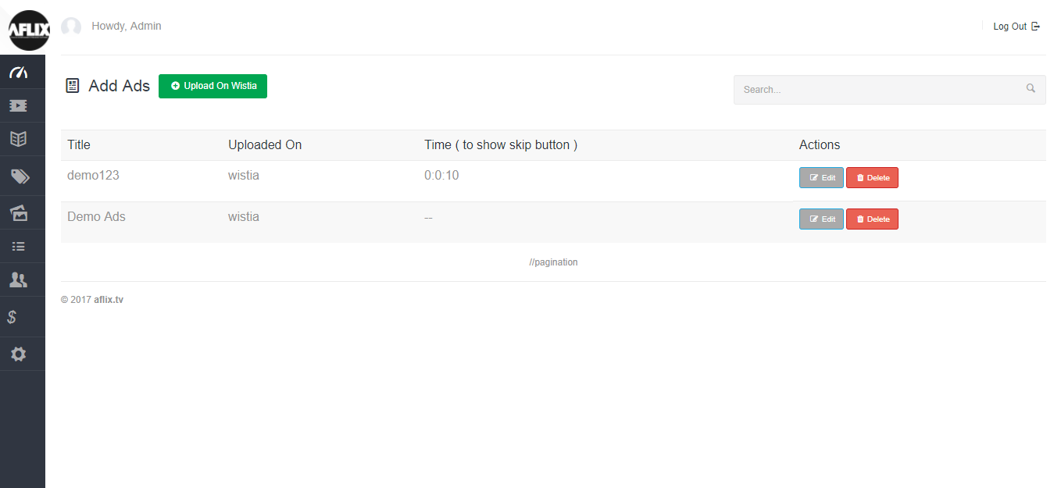

If admin want to edit existing ad then he can edit it.

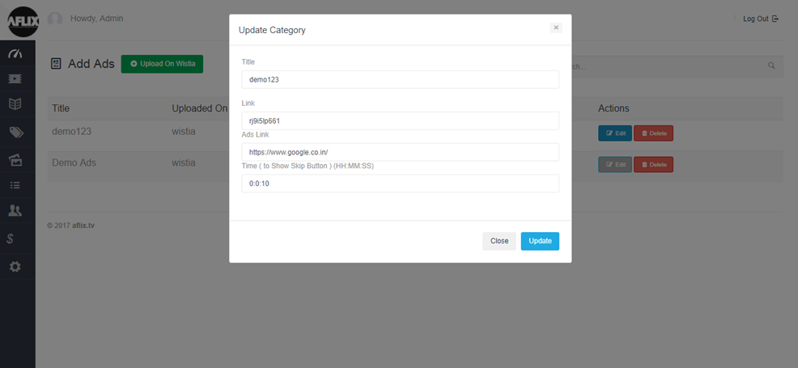

### Assign Video list

In this section admin can view the video category

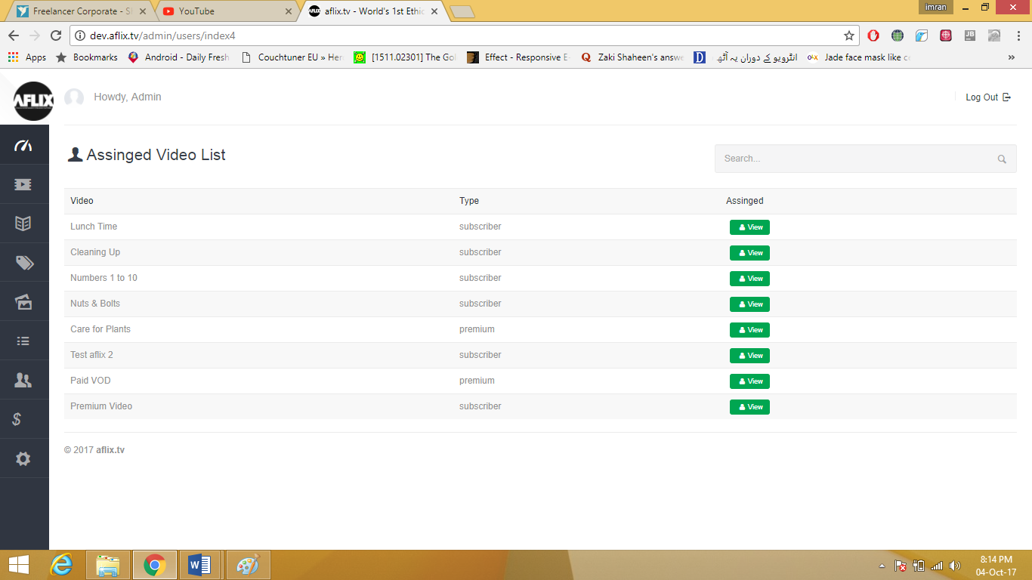

And if admin click on view button then admin can see detail also

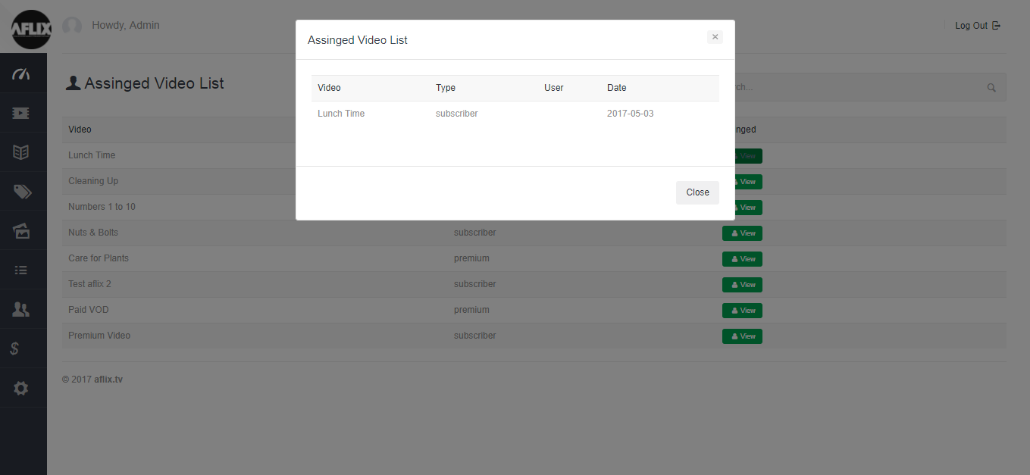

### Manage category thumbnail

In this section admin can manage homepage thumbnails. Admin can edit thumbnail admin can block thumbnails and admin can activate the thumbnails.

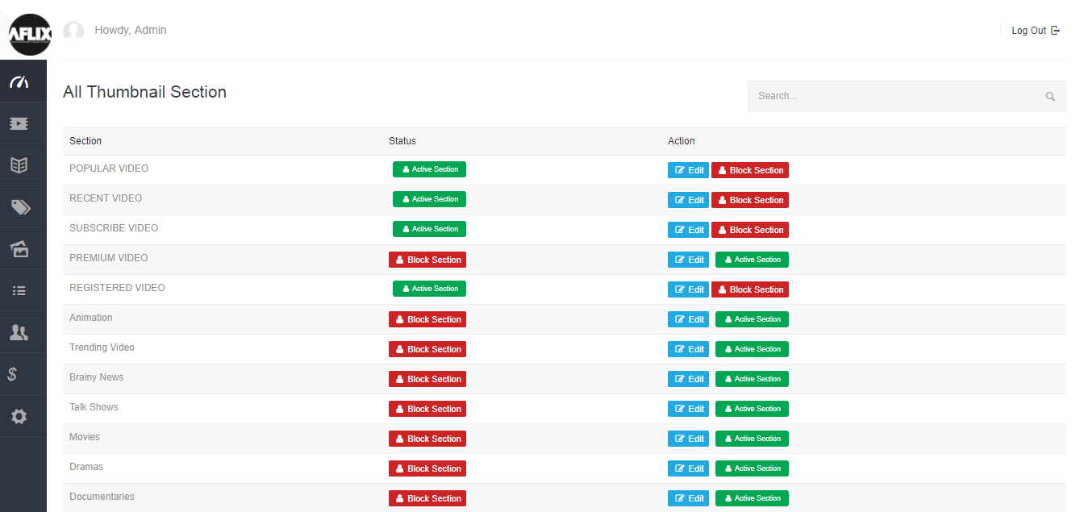

Admin can edit thumbnail by clicking on it.

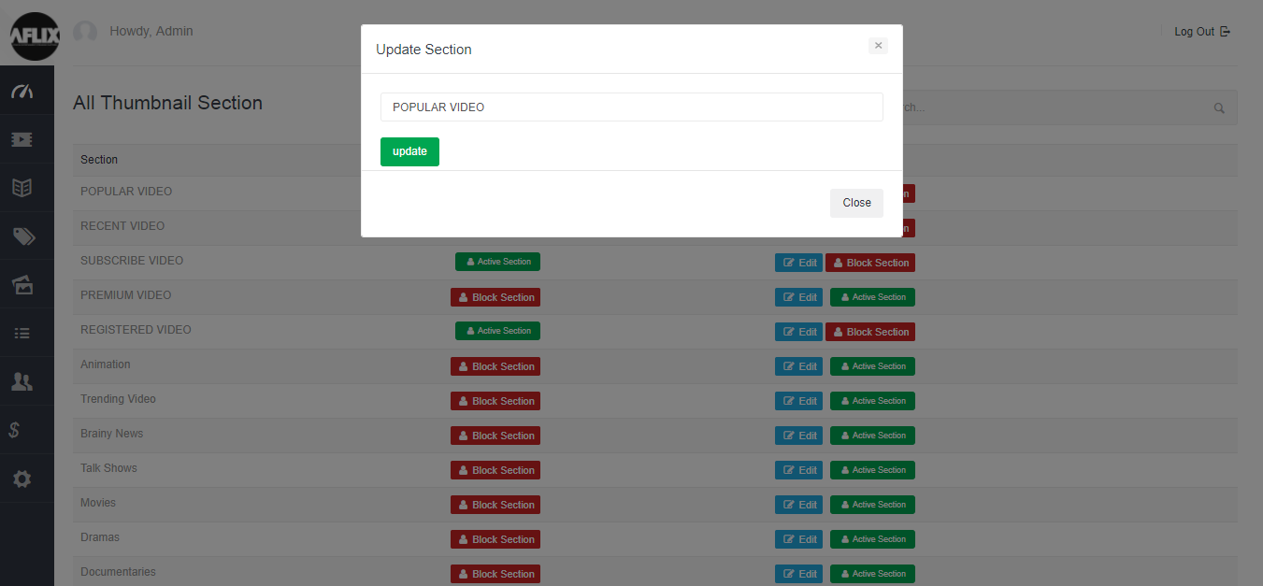

### All subscription plan

In this section admin can see all plans both monthly and yearly. Admin can edit them and can delete them. And if admin want to add new plan then admin can add plan here.

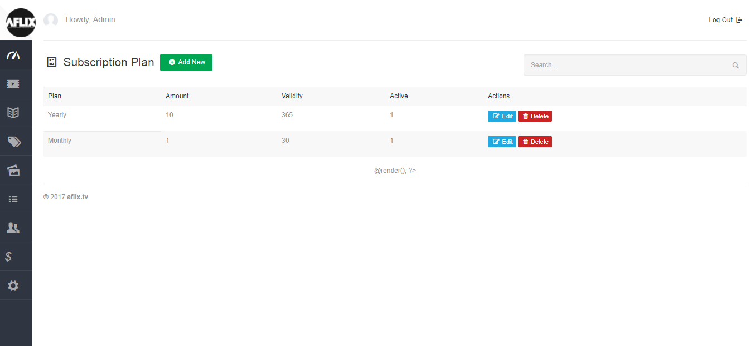

Admin can update yearly subscription

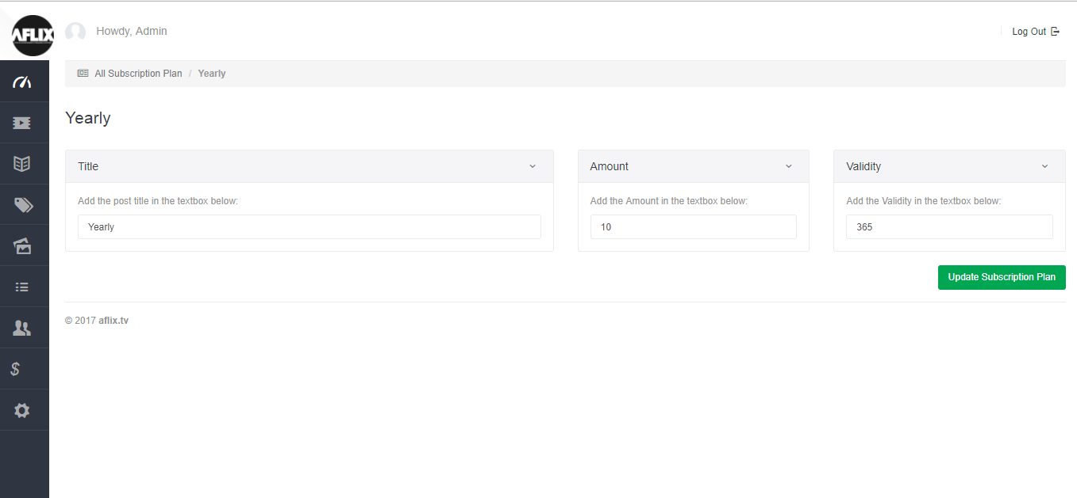

Admin can edit monthly subscription rates as well.

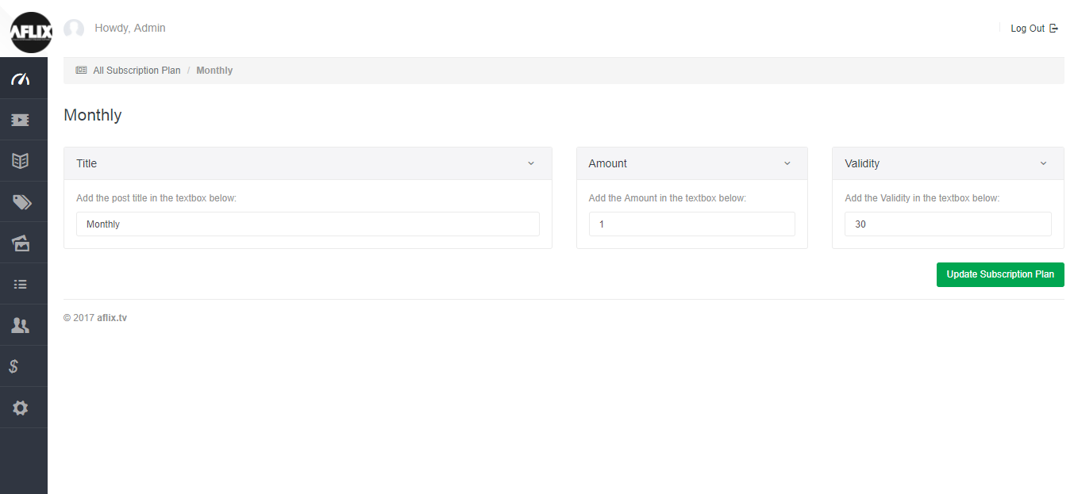

### Add New Subscription Plan

In this section admin can add new plans

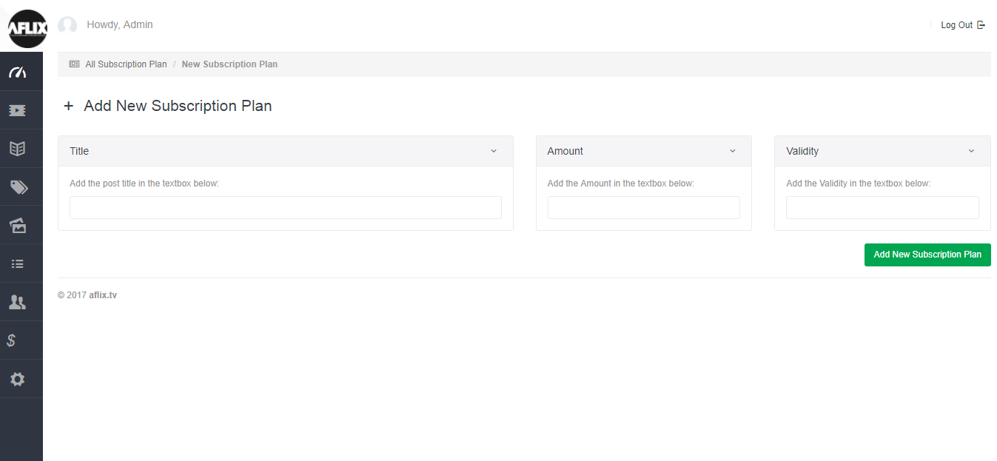

### Coupons

In this section admin can add coupons on different occasions

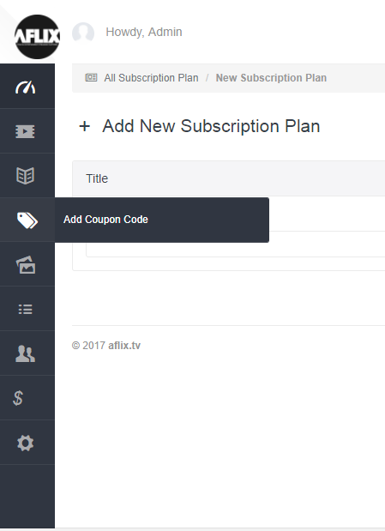

Admin can add new coupons can delete it and can edit it.

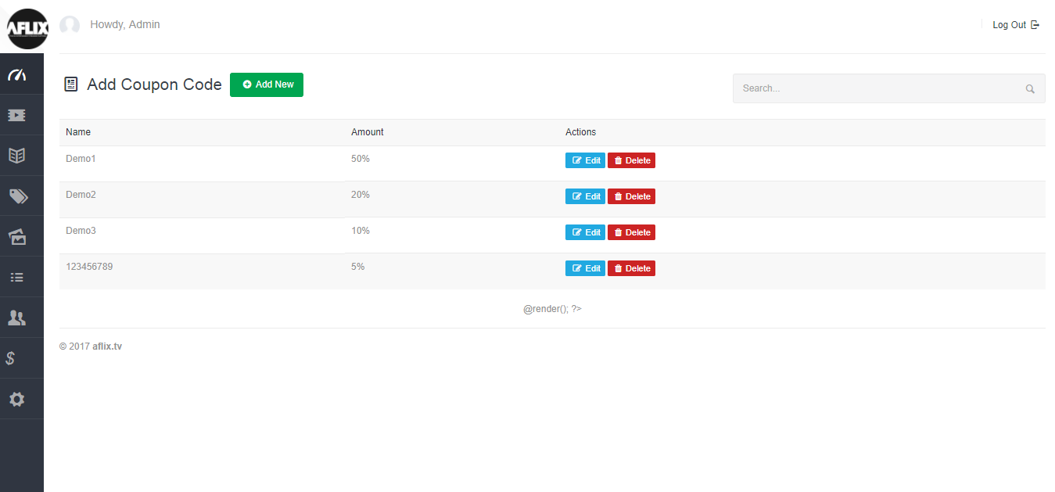

Admin can edit coupon like below.

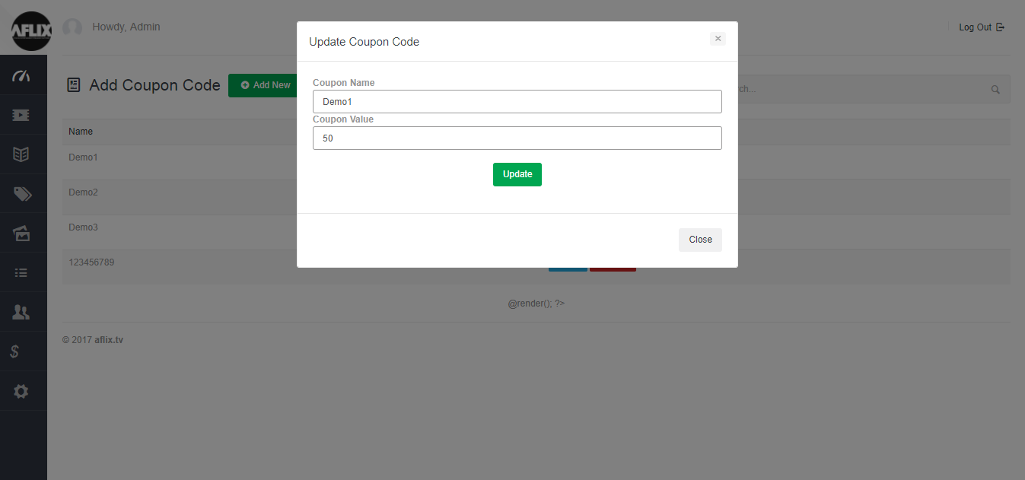

### Manage revenue

There is manage revenue section admin can manage and see revenue.

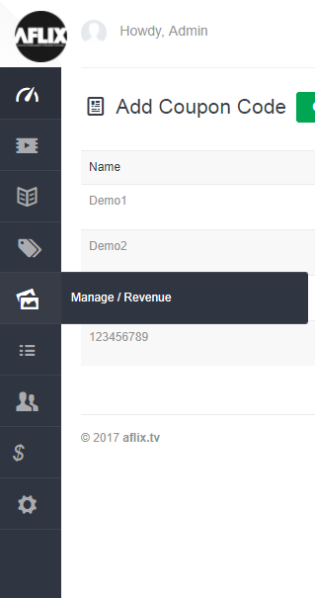

In this section admin can see all earnings of videos. admin can see revenue of premium and subscription videos. admin can edit them and can delete them according to his needs.

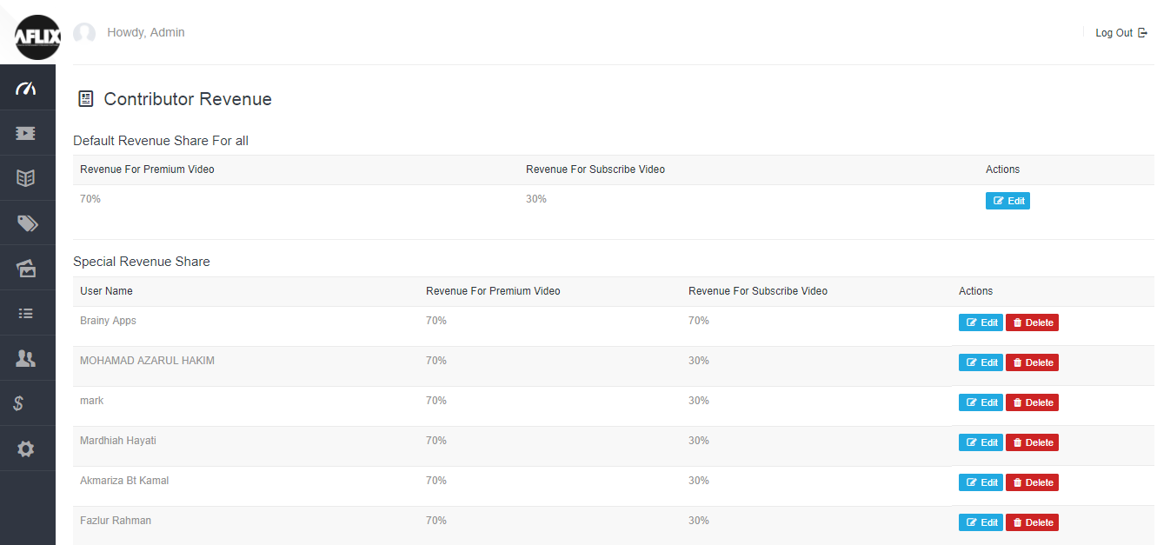

### Menu

In this section admin can see menu items

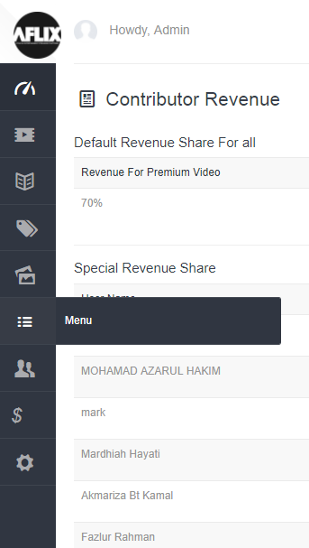

In this section admin can edit menu can delete menu and can add new menu as well

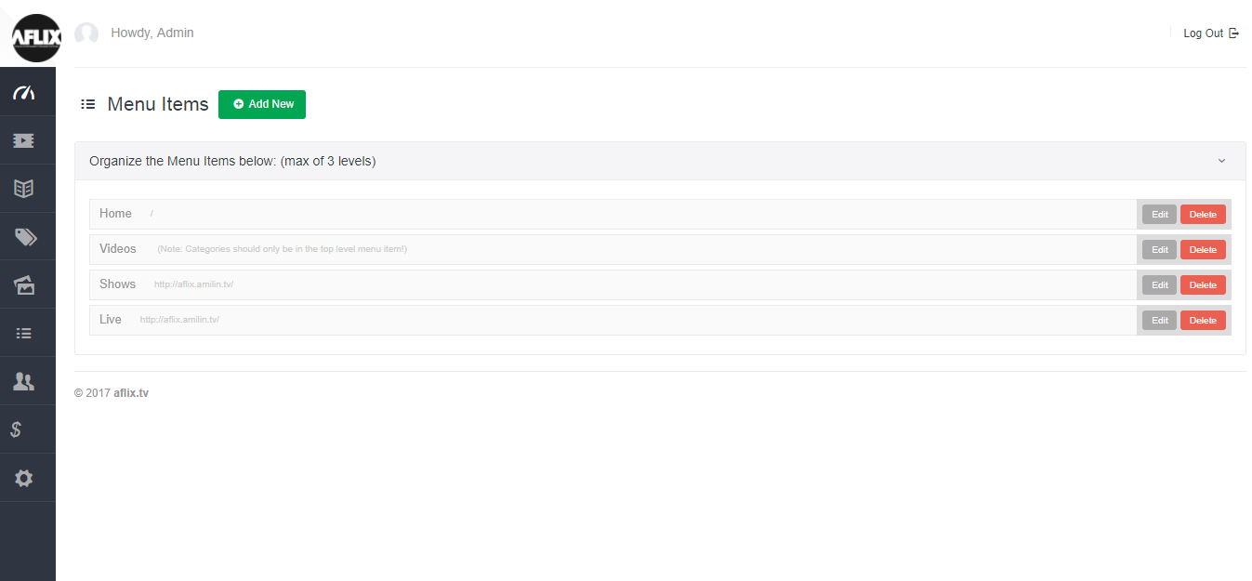

When admin click on edit menu then following popup will appear where he can set all parameters.

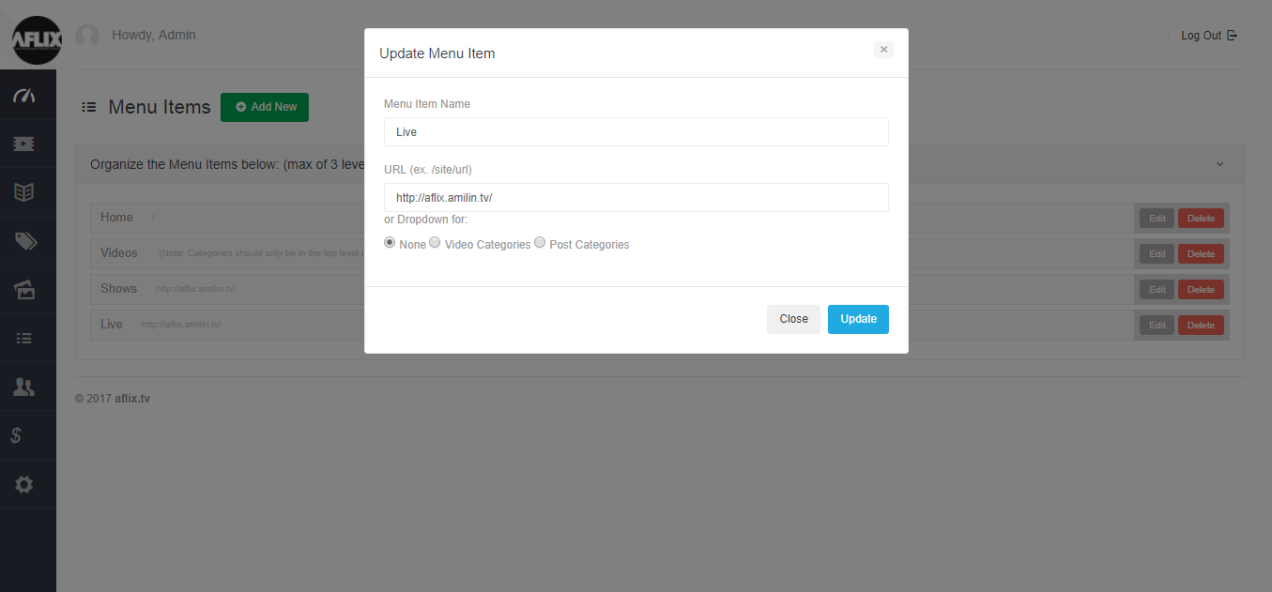

If admin want to delete any menu then he will click on delete button and a confirmation message will appear and he can click on ok button then menu will disappear.

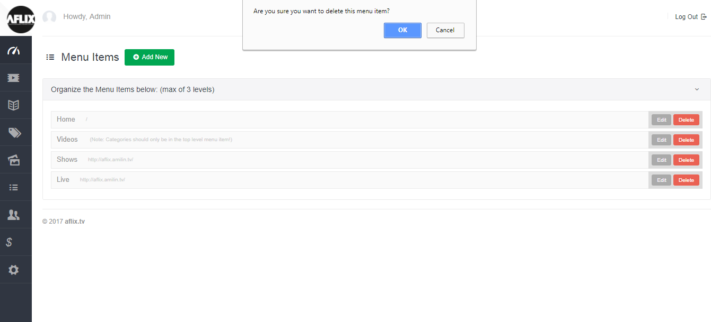

### User Section

There is a section of user here admin can handle all users.

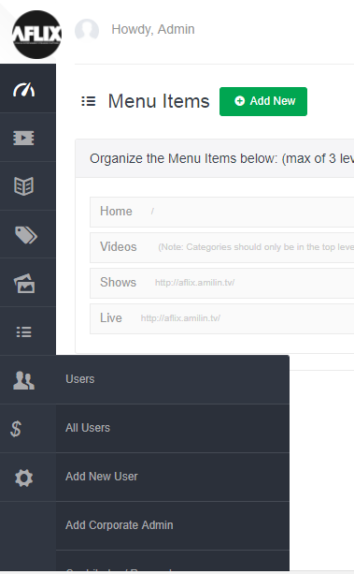

### All Users

In this section admin can see all users their subscription date and ending dates. And he can delete them or edit then or can activate and deactivate uses as well.

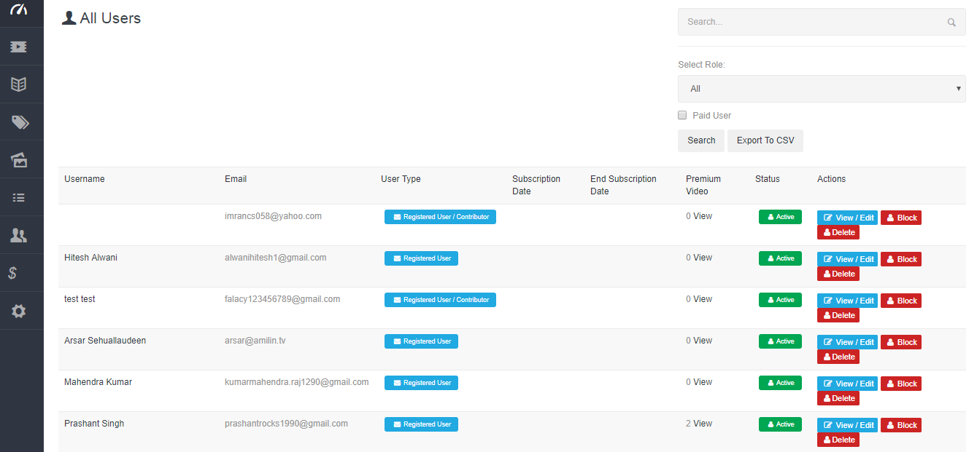

### Add corporate user

In this section admin can add new corporate users.

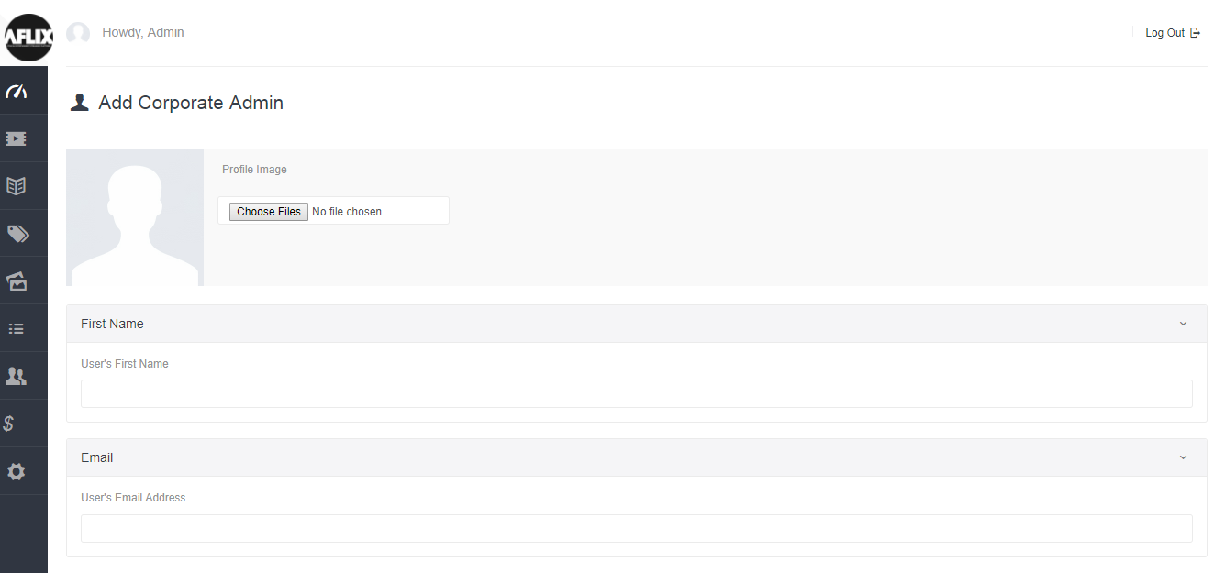

### All Users Contributor Request

In this section admin can see all requests from contributor’s admin can accept them or reject them.

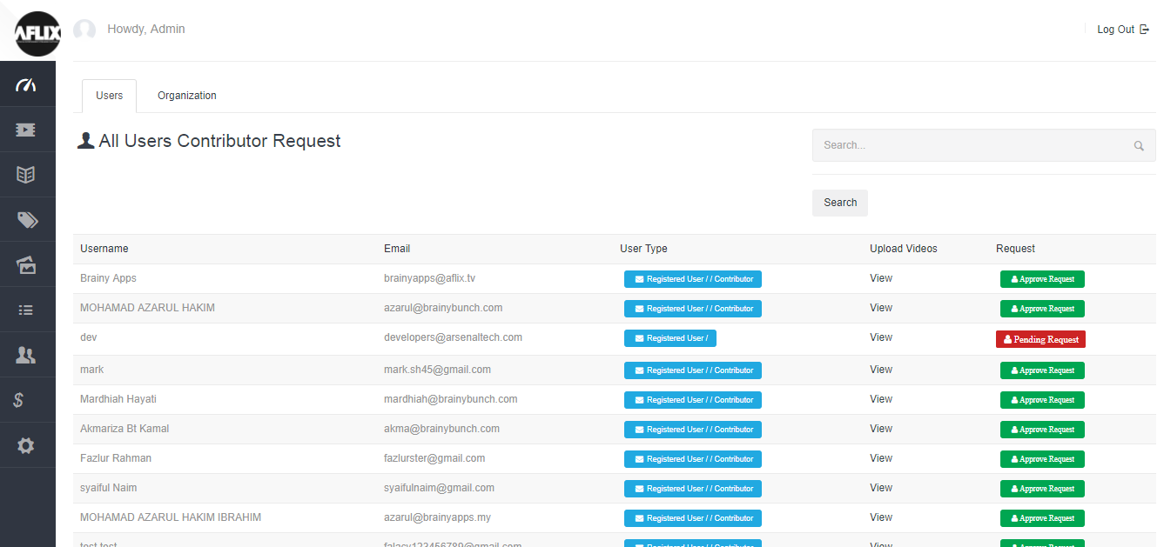

### Payments

There is a payment section for managing payments

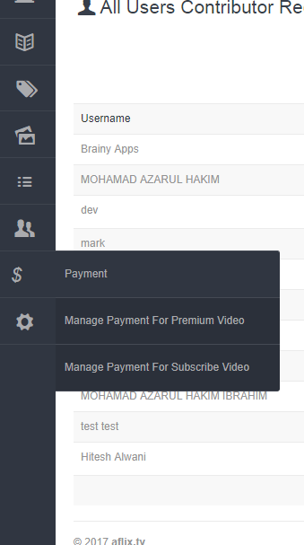

### Manage Payment for Premium Video

Admin can view admin and contributors payments there.

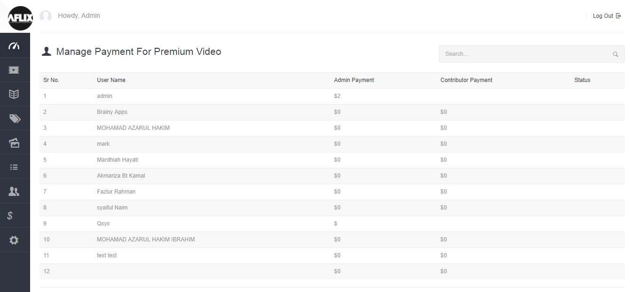

### Manage Payment for Subscriber Video

Admin can see subscriber’s video payments as well as their shares.

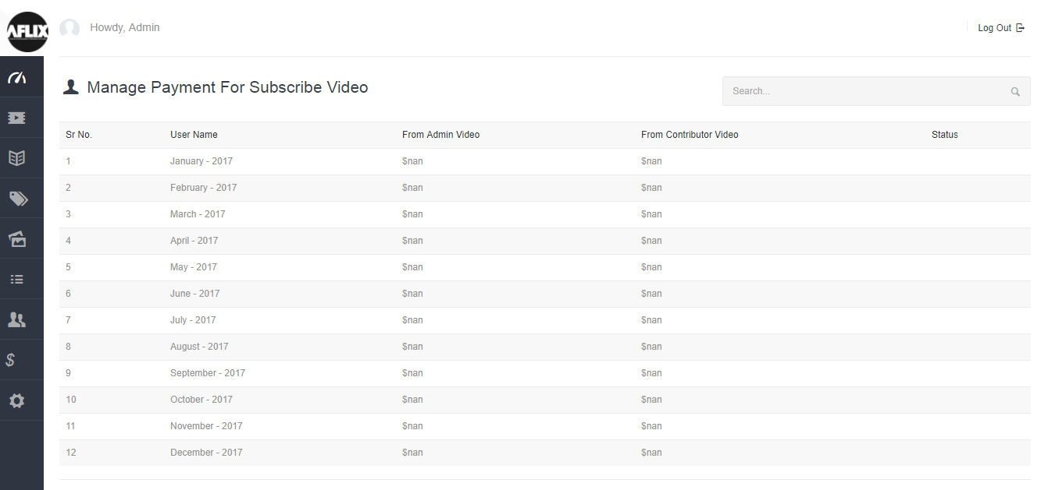

### Settings

There is setting section as well

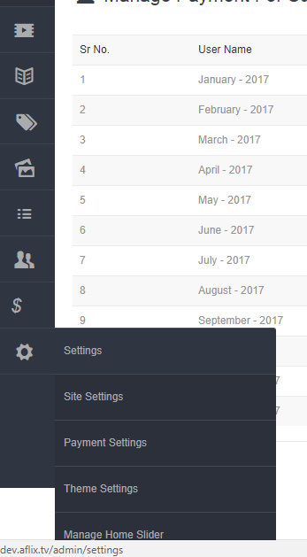

### Payment Settings

In this section admin can change stripe and paypal payment options.

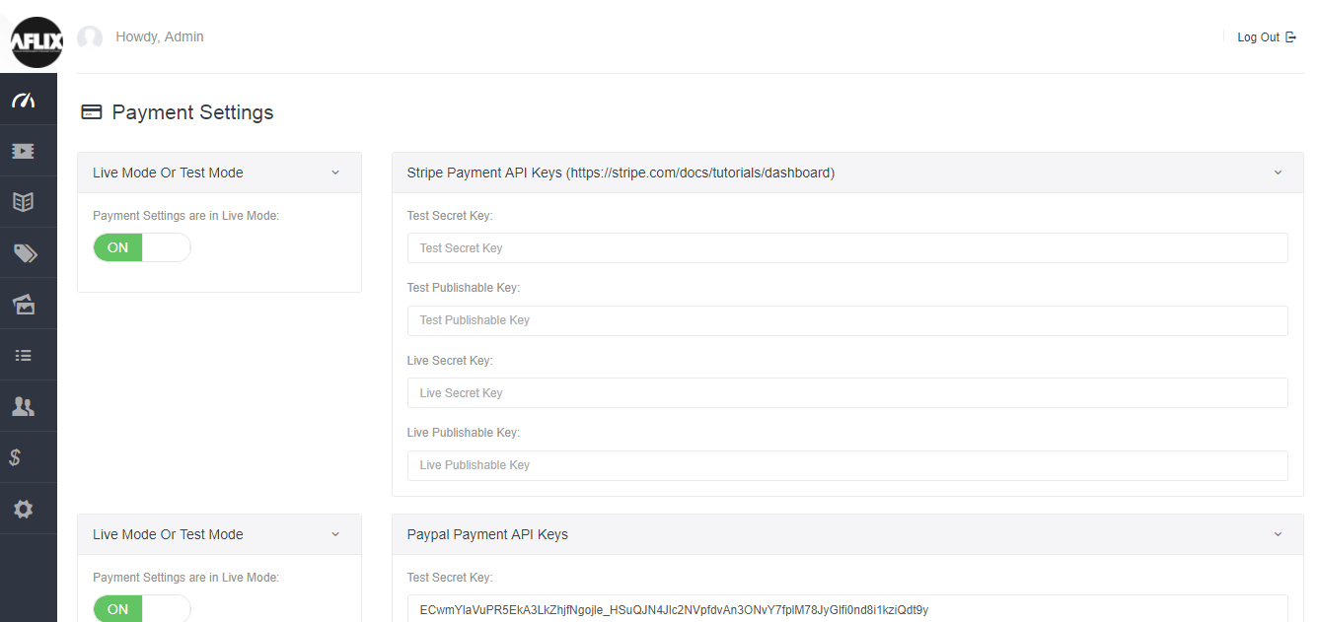

### Manage Home Banner

In this section admin can change home banner and he can change images appearing in the home banner.

